A Project Report on

Info Vault system

Submitted in partial fulfillment of the requirement of BCE3009

Of

BE. Computer



**Submitted to:**

Purbanchal University

Biratnagar, Nepal

**Submitted By:**

Prajwol Dhungana <730782>

Utshab Bhatta <730793>

**KANTIPUR CITY COLLEGE**

Putalisadak, Kathmandu

11th December, 2023

A Project Report on

An

Info Vault system

Submitted in partial fulfillment of the requirement of BCE3009

BE. Computer

**Submitted To:**

Purbanchal University

Biratnagar, Nepal

**Submitted By:**

Prajwol Dhungana <730782>

Utshab Bhatta <730793>

**Project Supervisor:**

            Ashim  KC

**KANTIPUR CITY COLLEGE**

Putalisadak, Kathmandu

11th December, 2023

**Table of Contents**

Abstract i

Acknowledgement .ii

Declaration iii

Supervisor Approval iv

Certificate form Department v

1.Introduction 1

1.1.**Overview** 1

1.2**Problem statement** 1

1.3**Objective** 2

1.4**Features** 2

1.5**Significance** 3

1.6**Scope and limitations** 3

1.7**Organization of document** 4

2.Literature Review 5

2.1. **P**HONEBOOK **M**ANAGEMENT **SYSTEM Overview:** 5

2.2. **F**ull Contact  **Overview:** 6

3.Methodology 8

3.1. **Software development life cycle** 8

3.2. **Technologies and tools used** 8

3.3. **Assignment of roles and responsibilities** 9

4.Algorithm and Flowchart 11

4.1. **Algorithm:** 11

4.2. **Flowchart:** 13

5.System development and Implementation 14

5.1. **Programming platform** 14

5.2. **Operating Environment** 14

6.Conclusion 15

7.References 16

**Abstract**

The Info Vault  addresses the limitations of traditional contact management by providing a user-friendly interface with robust search and sorting functionalities. It enhances contact organization through customizable categories and efficient data synchronization across devices. The system prioritizes security and privacy, incorporates seamless contact sharing options, integrates with external applications, and introduces advanced features like statistics and data exporting. This comprehensive solution aims to streamline data management, offering users an intuitive and secure platform for effective communication in the digital age.

**i**

**Acknowledgements**

We would like to express our  heartfelt acknowledgments to all those who have contributed to the successful completion of this project. First and foremost, We are deeply grateful to our project advisor [Ashim Kc] for his invaluable guidance, unwavering support, and expert insights throughout the journey. His mentorship has been instrumental in shaping the direction and quality of this work.

We would also like to extend my gratitude to our colleagues and peers who generously shared their knowledge and perspectives, enriching the project's depth and breadth. Their constructive feedback and collaborative spirit have been crucial in refining the ideas presented here.

Furthermore, We would like to thank our family and friends for their continuous encouragement and understanding.

This project stands as a testament to the collective effort and support of all those mentioned above, and many more who have contributed in various ways. Thank you for being an integral part of this journey.

**Members:**

Prajwol Dhungana <730782>

Utshab Bhatta <730793>

**ii**

**Declaration**

I declare that this project titled “Info Vault” submitted in partial fulfillment of the BE Computer is a record of the original work carried out by us under the supervision of Ashim Kc  and has not formed the basis for the award of any diploma, in this or any other Institution or University. In keeping with the ethical practice in reporting information, due to acknowledgements have been made where the findings of others have been cited.

Prajwol Dhungana<730782>

Utshab Bhatta<730793>

Date: 11th December, 2023

**iii**

**Supervisor Approval**

This is to certify that the major project entitled Info Vault system undertaken and demonstrated by Prajwol Dhungana<730782> and Utshab Bhatta<730793> has been successfully completed under my supervision as a partial fulfillment of the requirements for the degree of BE. Computer, Third Semester under Purbanchal University. I, henceforth, approve this project to be awarded the certificate by the concerned authority.

During supervision, I found students hardworking, skilled and ready to undertake any professional work related to this field in future.

Ashim Kc

Project Supervisor

Lecturer, Computer Department

Date:

**iv**

**Certificate From Department**

Following the Supervisor’s Approval and Examiners’ Acceptance, the project entitled “Info Vault” submitted by Prajwol Dhungana<730782> and Utshab Bhatta<730793> a partial fulfillment of the requirements for the degree of BE. Computer third Semester under Purbanchal University has been officially awarded by this certificate.

I wish the students all the best for their future endeavors.

Er.Subhash Rajkarnikar

HOD, Computer Engineering

Date:

**v**

**1. Introduction:**

The “Info vault” application works specifically for keeping records of people. The “Info vault” application contains a set of basic functions for adding, searching, updating, deleting, exporting data’s and it is possible to view the recent data’s as well as the data’s can be exported for further use in .txt format. This “Info vault” system allows us to store data such as Name, address, contact number, official email etc. We can add, find, edit, search and delete data to the system.

**1.1 Overview:**

The Info Vault addresses the limitations of traditional contact management by providing a user-friendly interface with robust search and sorting functionalities. It enhances contact organization through customizable categories and efficient data synchronization across devices. The system prioritizes security and privacy, incorporates seamless contact sharing options, integrates with external applications, and introduces advanced features like statistics and data exporting. This comprehensive solution aims to streamline data management, offering users an intuitive and secure platform for effective communication in the digital age.

**1.2 Problem Statement:**

Some people still use hardcopy notebooks to store information such as emails, phone numbers, and other details which makes it difficult to search for and modify information. To address this issue information vault is created so that we could easily add, edit, and erase search information that we had added to them digitally.

1

**1.3 Objectives:**

1. For efficient Data Management:

This console system prioritizes user-friendly storage, retrieval, modification, and deletion of information, with the added benefit of exporting both raw data and graphical representations for comprehensive data management.

1. FOr Versatile Data Handling:

Users can export data into .txt files, promoting its use for diverse tasks beyond the system's core functions. The system's emphasis on easy retrieval ensures quick access to essential information.

**1.4 Features:**

* **Information Management:** This system allows users to create, edit, store and delete information. It provides fields to store various information about each contact, such as name, phone number, email address, physical address, and additional notes.
* **Search:** Users can search for details of a person by simply writing the name of the person from the block of information.
* **Data security**: The system is password protected so that none can easily access the data without a valid password
* **Modify:** If a person has to edit any details, they can simply edit them
* **Export:** Data’s can be further exported into .txt file for further use
* **Customization:** To allow users to customize and configure the system based on their specific needs and preferences.

2

* **User friendly design:** The design of the system is so friendly that any authorized user can get familiar to it quickly.

**1.5 Significance**

The “Info vault” represents a pivotal advancement in organizing and accessing contact information efficiently and intuitively. By providing a centralized digital repository for storing and retrieving contact details, this system revolutionizes the way individuals and organizations manage their communication networks. With features like searchable databases, customizable categories, and quick updates, the “Info vault” streamlines the process of finding and updating contact information, saving valuable time and minimizing errors. This technological innovation not only enhances personal convenience but also bolsters the productivity and connectivity of businesses, fostering seamless communication and fostering more meaningful interactions in our interconnected world.

**1.6 Scope and Limitations**

The scope of “ Info Vault” is extensive, offering a range of benefits and functionalities for both individuals and organizations. Its primary scope includes:

**1.Efficient Contact Organization:** The system allows users to store and categorize contact information in a structured manner, making it easy to find specific contacts when needed.

**2.Quick Access:** Users can swiftly retrieve contact details without flipping through physical directories, leading to improved efficiency and reduced time wastage.

**3.Data Updates:** Users can easily update contact information as it changes, ensuring that the stored data remains accurate and up-to-date.

3

**4.Search and Filter:** The system typically offers search and filtering capabilities, enabling users to locate contacts by various criteria such as name, organization, location, and more.

       However, there are certain limitations to consider:

1. **Dependency on Technology:** The system relies on technology infrastructure, which might be susceptible to technical glitches, crashes, or compatibility issues.
2. **Data Accuracy:** Users must proactively update the system to ensure accurate contact information. Failure to do so could lead to outdated or incorrect details.
   1. **Organization of document**

The document on the Info vault system is organized systematically to provide a clear and comprehensive overview. It begins with an introduction that outlines the significance of the Info vault system and its role in the real market. This is followed by a section detailing the key stakeholders involved. The document then delves into the challenges and issues currently plaguing the system like data loss, data security. To address these challenges, a proposed solution is presented, focusing on the implementation of a standardized digital platform for record keeping. The document further discusses the potential benefits of this solution.

4

1. **Literature Review**
2. **Phone Book Management System:**

A Phone Book Management System is a modern software application designed to efficiently store, organize, and manage contact information in a digital format, replacing the conventional paper-based phone book. This system consists of a user-friendly interface, a database for storing contacts, search capabilities, and options to add, edit, or delete contacts.

**Pros:**

* **Efficiency:** Quick and easy access to contact information.
* **Searchability:** Rapidly locate specific contacts.
* **Organization:** Grouping and categorization enhance contact organization.
* **Data Backup:** Protection against data loss through backup features.
* **Accessibility:** Access contact data from multiple devices.
* **Environmental Impact:** Eliminates the need for physical paper usage.

**Cons:**

* **Dependency on Technology:** Relies on software and devices; if they fail, access to contacts might be compromised.
* **Data Security:** Vulnerable to hacking or data breaches if not properly secured.
* **Maintenance:** Requires updates, patches, and maintenance to ensure smooth operation. 5
* **Privacy Concerns:** Storing personal contact information digitally raises privacy concerns if not properly protected.

1. **Full contact:**

Full Contact is a comprehensive contact management system designed to enhance the accuracy, organization, and accessibility of contact information. By aggregating data from various sources such as email accounts and social media profiles, Full Contact creates unified contact profiles that are enriched with up-to-date details. The system's cross-platform synchronization ensures consistent information across devices and applications. It offers features for categorizing contacts, identifying and merging duplicates, and integrating with different software tools. Full Contact’s focus on data accuracy and privacy, along with its time-saving benefits, make it an efficient solution for professionals and businesses aiming to streamline their contact management and communication processes.

**Pros of Full Contact:**

* **Accurate and Enriched Data:** Full Contact’s contact enrichment ensures that your contact information is not only accurate but also enriched with additional details from various sources, making your contact profiles more informative.
* **Time Savings:** The system saves time by automatically updating and organizing contact details, reducing the need for manual data entry and maintenance.
* **Efficient Communication:** With enriched and organized contact profiles, you can communicate more effectively, as you have a better understanding of your contacts' backgrounds and roles.

**6**

* **Cross-Platform Accessibility:** Full Contact’s synchronization features ensure that your contact information is consistent and accessible across all your devices, allowing you to stay connected wherever you are.
* **Reduced Duplication:** The system's ability to identify and merge duplicate contacts prevents clutter and maintains data integrity within your contact database.
* **Professional Networking:** Full Contact is particularly useful for professionals who want to maintain a comprehensive and up-to-date database of their business contacts, helping them nurture relationships effectively.

**Cons of Full Contact:**

* **Data Security and Privacy:** While Full Contact emphasizes data privacy, sharing personal or sensitive information with any third-party service can raise concerns about data security and confidentiality.
* **Dependency on Technology:** Like all software-based solutions, Full Contact is dependent on technology. Technical issues, outages, or changes to the platform can potentially disrupt access to your contact information.
* **Customization Limitations:** While Full Contact provides various features, some users might require specific customizations that the system might not offer, leading to potential limitations in catering to unique needs.

7

**3.Methodology:**

3.1. **Software Development life cycle:**

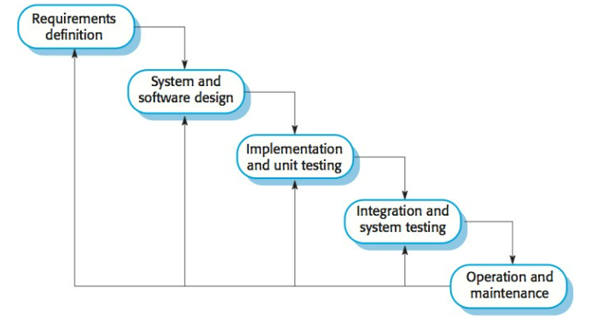

fig 1.1: SDLC

**3.2. Technology and tools used:**

To create this Info vault system, we used various tools and technologies and these were essential for us to complete the project in given time. The technologies and tools that we used are Dev C++. They were very essential for us as because of those tools and technologies we could communicate with each other and create a fully working system in given time frame.

**8**

**Specified programming language being used for the development:**

Specified programming language being used for the development The specific programming language used is C. C is a versatile and powerful programming language that blends the features of procedural paradigm. Known for its efficient and performance, C is widely used in developing a range of application from system software and games to high performance applications. Its key strengths include memory management control through features like pointers and ability to directly access hardware resources.

**3.3.Assignment of roles and responsibilities:**

|  |  |
| --- | --- |
| Member name | Roles and responsibilities |
| Prajwol Dhungana<730782> | Documentation, Code |
| Utshab Bhatta<730793> | Documentation, Code |

9

**4. ALGORITHM AND FLOWCHART:**

**Gantt Chart:**

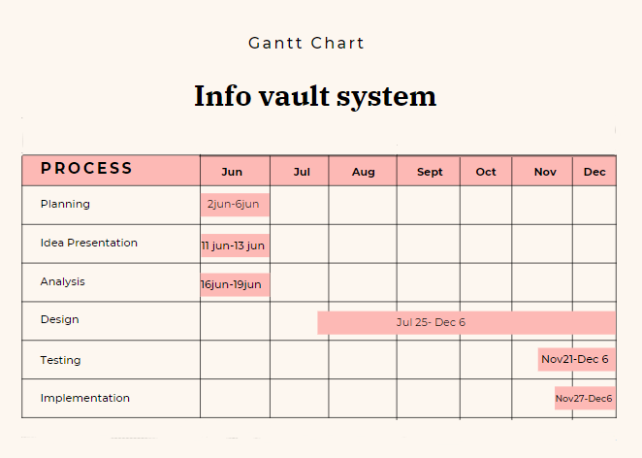

fig 1.2: Gantt chart

**10**

**4.1. Algorithm:**

Step1: Enter the login Id and password (If login Id and password are correct enter the program else end the program)

Step 2: Ask the user to enter the choice so that the program can be carried out

Step 3:

 Case1:

        1.1 Ask the user to enter the name of the employee or student

        1.2 Enter the address

        1.3 Enter the department

        1.4 Enter the email address

        1.5 Enter the mobile number

Case 2:

         2.1 Ask the name of the person to delete the data

         2.2 If name found delete the data else display data not found

Case 3:

         3.1 Ask the name of the user

         3.2 If name is found display the data of that name else display data not found

Case 4:

         4.1 Display all the data of file

Case 5:

         5.1 Ask the name of the user

         5.2 If name is found ask name, address, department, email, phone and rewrite

         5.3 else display data not found

Case 6:

         6.1 If there is at least a data export the data’s of the system into .txt file in well

    formatting else display error

11

Case 7:

         7.1 Ask the name of the department

         7.2 If the name of department is found display number of records with that

department and show bar graph

         7.3 Else display no record found

Case 8:

         8.1 Show all the data’s of past 10 days

Case 9:

         9.1 Logout and ask for Id and password again

Step 3: Exit the program

12

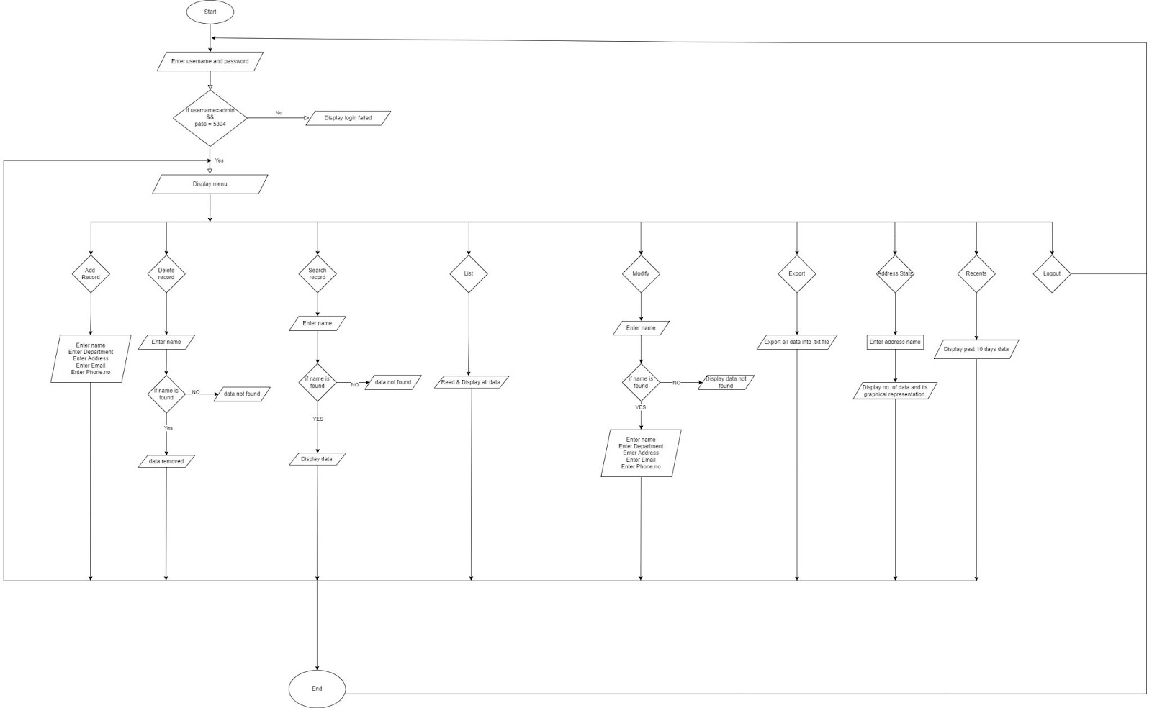**4.2. Flowchart:**

**13**

**5. System development and Implementation:**

Software development encompasses the entire lifecycle of creating application, from initial concept to coding, testing and deployment. Implementation on the other hand focuses specifically on putting the developed software into practical use ensuring it integrates smoothly into the intended environment and serves its intended purpose effectively.

**5.1. Programming platform:**

Dev C programming platform to develop and implement the C code. Dev C serves as a comprehensive integrated development environment (IDE) for C and C++ programming languages, providing a user-friendly interface and a robust set of tools to streamline the development process. The platform offers features such as syntax highlighting, code completion, and debugging functionalities, enhancing code readability and facilitating efficient troubleshooting. Additionally, Dev C supports project management, allowing for the organization of code files and resources in a structured manner. The compiler integration within Dev C ensures seamless code compilation, while the built-in editor simplifies code editing tasks

**5.2. Operating platform:**

An operating environment refers to the underlying system, hardware, and software components that provide the necessary resources for the project to run smoothly. The software used for the development of this project are:

      Windows 10 pro

The hardware which is used for the development of this project is

14

**Hardware 1**:

Device name:  Acer Aspire 5

Processor:   i5- 12th Gen Intel(R) Core (TM)

System type:   64-bit operating system, x64-based processor

**6. Conclusion**

The Info Vault project delivers an efficient and secure solution for managing personal information using C programming. Key features include a password-protected login system, file handling for persistent data storage, and functionalities for adding, deleting, searching, modifying, listing, exporting, and providing statistics.

The system's highlights include a recent records feature for quick access to the latest entries, and time stamps for historical tracking. While the project successfully meets its objectives, potential future improvements could focus on enhanced search options, additional data validation, and UI enhancements.

In summary, the Info Vault system is a robust information management tool that balances simplicity with functionality, laying the groundwork for potential future enhancements.

**15**

**7. References**

1. Geeksforgeeks:

Generate time stamp within the file

URL: <https://www.geeksforgeeks.org/time-function-in-c/>

1. Draw.io:

Drawn Flowchart

URL: https://app.diagrams.net/

1. Stack Overflow

<https://stackoverflow.com/>

1. Canva

For designing gantt chart

https://canva.com/templates/?query=gantt-chart  **16**